

FAMILY PRACTICE
Armada Road, Whitchurch, BRISTOL BS14 0SU. TEL: 01275 832285
GP Partners; Dr K Jones & Dr I Da Costa & Dr J Frawley.

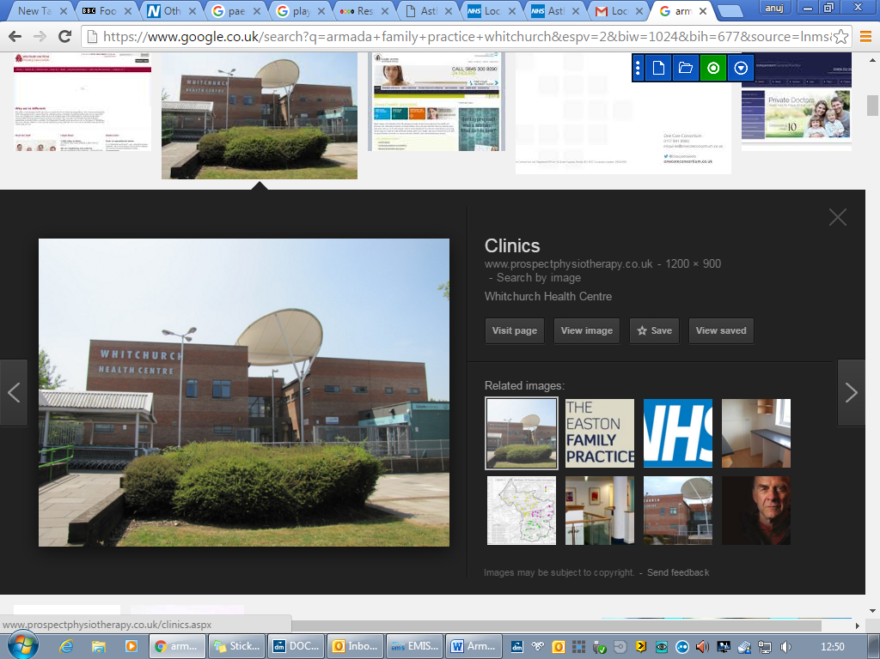
Great opportunity to join a friendly and supportive practice.

Advanced Practitioner,
pay A4C equivalent based on skills and experience
4-8 sessions.

About us

The Armada Family Practice works from a modern purpose-built health centre with a practice population of circa 16,300 patients. We are part of Swift Primary Care Network which covers approximately 80,000 patients across South Bristol.

Our clinical team comprises of GP Partners, Salaried GPs, Advanced Practitioners, Paramedic Practitioners, Practice Community Nurses, Practice Pharmacists, MSK practitioner, Mental health nurse, Health and Wellbeing coach, Practice nurses, HCAs, General Practice Assistants and a large administration team.

- Excellent employment package
- On call team, you are never on your own.
- Compact practice area with easy parking.
- Training Practice
- Daily get together over coffee
- EMIS Web clinical system
- CQC rated “Good”
- Future Partnership opportunities

All our appointments are booked by our experienced care navigation team who ensure that patients are booked in with the right clinicians at the right time. They use a navigation tool called Sentiers which has been adapted to meet our needs and appointment system.

Job Description

Main Objectives of Post

- To provide holistic health care for patients including those with undifferentiated and undiagnosed problems using advanced clinical skills.
- To assist the workload of our busy practice by dealing with requests for advice, appointments and visits, and carrying out consultations with patients as required within the scope of the post, prescribing as necessary within guidelines for non-medical prescribing.

Main Responsibilities

- To undertake face to face and remote consultations for both same day and routine appointments, providing appropriate care and treatment to patients

- To undertake home visits for selected patients with the agreement of the on-call team.

- Visit patients in nursing homes and undertake ward round as necessary

- To participate in the practice on call team

- Undertake all necessary administrative duties, referrals, letters, manage patient results and take appropriate action.

- Prescribing duties, EPS.

- To maintain knowledge of medical developments within primary care and to ensure all new clinical guidelines are implemented and adhered to.

- To undertake regular audits as required NHS England, Bristol ICB and identified key practice developments, particularly in relation to long-term condition management.

- To be available to offer flu vaccinations or similar when conducting home visits.

- To be involved in research projects or any other practice projects as appropriate.

- To promote a team approach to patient care through liaison with other Primary Health Care Team Members E.g. Treatment Room, Community Nurses, Health Visitors, and Midwives.

- Attend all practice meetings as necessary

- To make efficient use of the EMIS system to record all consultations.

Please email the practice manager, Mrs Victoria Fyfe at Victoria.fyfe1@nhs.net to discuss further or arrange an informal visit.

Further practice information is available from our website: www.armadapractice.co.uk

